**ABOUT THE ERD**

Below is a schema for the PubMed articles with a MeSH heading “obesity”, selected in step number two and extracted in step number three. Note that journal information nor article information have not been factored out into their own entities, since the requirements did not specify more than what’s shown in the table PubMedRecord. Selecting articles based on titles or publication year is straightforward; selecting by authors or MeSH descriptors requires a join via their respective ‘set’ tables.

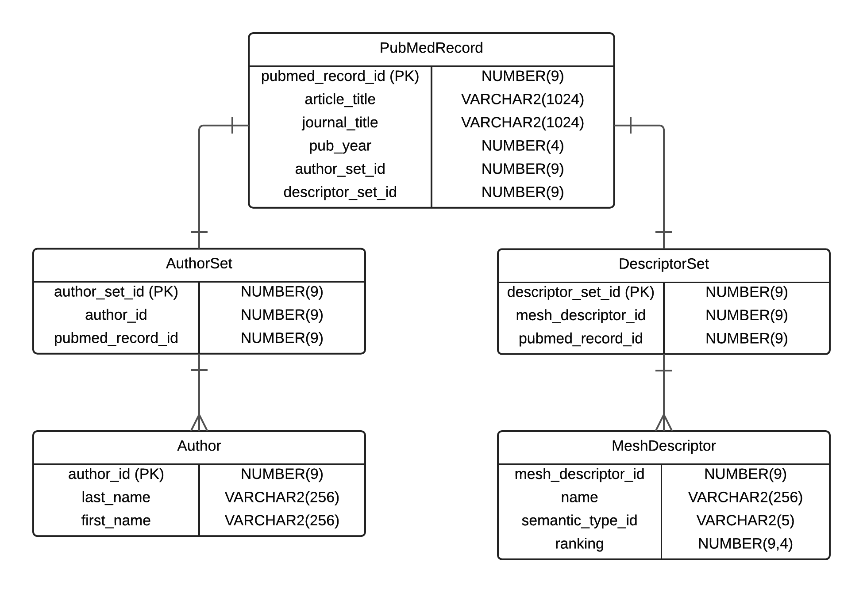

**Joseph Rose, Nov. 2015**